Investering aflevering 2
Question1
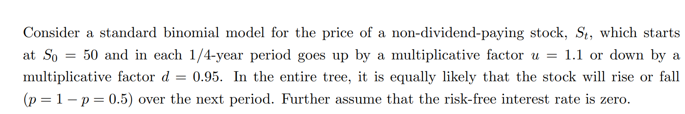
- Is the model arbitrage free and complete
We write the state price matrix after 1 period with the given information (we just adjust for 1 dollar in the underlying)
$$A=\left(\begin{matrix}d & u \\ 1+r_{f} & 1+r_{f}\end{matrix}\right)=\left(\begin{matrix}0.95 & 1.1 \\ 1 & 1\end{matrix}\right)$$
$$ψ=A^{-1}P={\left(\begin{matrix}0.95 & 1.1 \\ 1 & 1\end{matrix}\right)}^{-1}\left(\begin{aligned}1 \\ 1\end{aligned}\right)≈\left(\begin{matrix}0,6667 \\ 0,3333\end{matrix}\right)>0$$
The matrix is invertible and the stateprices are larger than 0 thus the market is complete and free of arbitrage
(we also have a “theorem” that says that a binomial model of stock prices with fixed up and downs is arbitragefree and complete if and only if $d<\frac{1}{d_{0,t}}<u$)

- Calculate $E^{P}[\frac{S_{1}}{S_{0}}-1]$
$$E^{P}\left[\frac{S_{1}}{S_{0}}-1\right]=\frac{E^{P}\left[S_{1}\right]}{S_{0}}-1=\left(0.5·0.95+0.5·1.1\right)-1≈0,025$$
- Find the risk neutral probabilities
$$q=\frac{1-d}{u-d}=\frac{1-0.95}{1.1-0.95}≈0,3333$$
$$1-q=\frac{2}{3}$$
- Calculate $E^{Q}[\frac{S_{1}}{S_{0}}-1]$ and interperate the result
$$E^{Q}\left[\frac{S_{1}}{S_{0}}-1\right]=\frac{E^{Q}\left[S_{1}\right]}{S_{0}}-1=\left(\frac{2}{3}·0.95+\frac{1}{3}·1.1\right)-1=0$$
The risk neutral measure ie exactly the measure where our expected return is equal to the risk free one since our risk free rate is 0 we expect our expected return to be the same
- Vi regner
$$E^{Q}\left[C_{0}\right]=q^{4}·c_{u^{4}}+4·q^{3}·(1-q)·c_{u^{3}d}+6·q^{2}{\left(1-q\right)}^{2}·c_{u^{2}d^{2}}+4·{q(1-q)}^{3}·c_{u·d^{3}}+{(1-q)}^{4}·c_{d^{4}}$$
$$={\frac{1}{3}}^{4}·23.205+4·\frac{1}{3^{3}}·{\left(\frac{2}{3}\right)}^{1}·13.225+6·\frac{1}{3^{2}}·{\left(\frac{2}{3}\right)}^{2}·4.60125≈2,956$$
- S is in a state equivalent with up up down
Thus we must have that the price either goes to 2up 2down or 3up 1 down
Thus the value of the option either goes to $c_{u^{3}d} or c_{u^{2}d^{2}}$
Hedging in the underlying and the bankacount must have 0 cashflows at time 1
Thus
$$Δ·63.2225+B=13.2225$$
$$Δ·54.60125+B=4.60125$$
$⇕$ Ligningssystemet løses for Δ,B vha. WordMat's 'Løs Ligninger' funktion,
$$Δ=1 ∧ B=-50$$
thus to hedge the short position in the option we must be long 1 underlying and loan 50
- What is the price of an American call with strike 50?
Since no dividends
$$c_{A}=C_{E}=2.956$$
- Price an American put with K=70

We calculate it backwards in each step deciding if we want to exercise I.e the walue at each node is exactly $\max{\{K-s_{t},P_{t},0}\}$ where the 0 is irrelevant since $P_{t}≥0$
This pricing gives us the tree
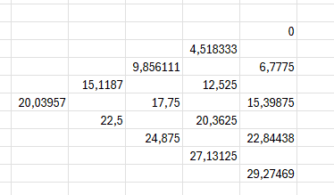
Pricing the put price at $20.04$
We also see that we basically always want to exercise early unless we hit up all the times
- $u=e^{μ·Δt+σ·\sqrt{Δt}},d=e^{μ·Δt-σ·\sqrt{Δt}}$ find $μ$ and $σ$
$$Δt=\frac{1}{4},u=1.1,d=0.95$$
$$u·d=e^{2·μ·Δt}$$
$$1.1·0.95=e^{2·μ·\frac{1}{4}}$$
$⇕$ Ligningen løses for μ vha. WordMat.
$$μ=0,08803$$
$$1.1=e^{0,08803·\frac{1}{4}+σ·\frac{1}{2}}$$
$⇕$ Ligningen løses for σ vha. WordMat.
$$σ=0,1466$$
Question 2
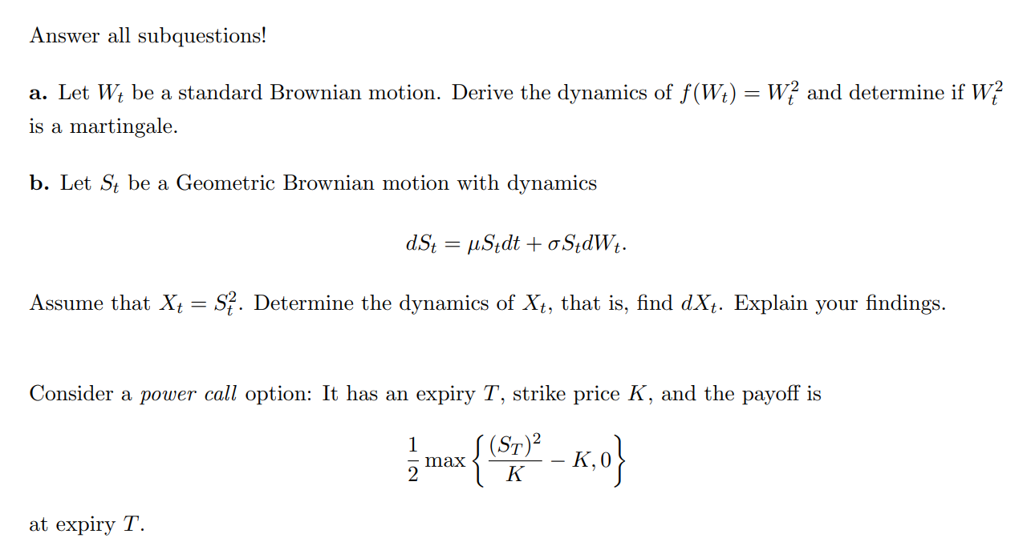
- Using itos lemma
$$df=\left(\frac{∂f}{∂t}+\frac{∂f}{∂S}·0+\frac{1}{2}·\frac{∂^{2}f}{∂S^{2}}\right)dt+\frac{∂f}{∂s}dW_{t}$$
$$=dt+2W_{t} dW_{t}$$
If the process is a matingale then the trend must be 0
Since the trend isent 0 the process isent a martingale
- $dS_{t}=μ·S_{t} dt+σ·S_{t} dW_{t} , X_{t}=S_{t}^{2}$
Again itos lemma
$$dX_{t}=\left(\frac{∂X}{∂t}+\frac{∂X}{∂S}·S_{t}·μ+\frac{1}{2}·\frac{∂^{2}X}{∂S^{2}}\right)dt+\frac{∂X}{∂s}dW_{t}$$
$$=\left(\frac{∂X}{∂S}·S_{t}·μ+\frac{1}{2}·\frac{∂^{2}X}{∂S^{2}}·σ^{2}·S_{t}^{2}\right)dt+S_{t}·σ·\frac{∂X}{∂s}dW_{t}$$
$$=\left(2·μ·S_{t}^{2}+σ^{2}S_{t}^{2} \right)dt+2·S_{t}^{2}·σ dW_{t}$$
Which can be redefined as a geometric brownian motion
$$=X_{t}\left(2μ+σ^{2}\right)dt+2σ·X_{t} dW_{t}$$
This is consistent with an exercise weve done for an arbitrary exponent
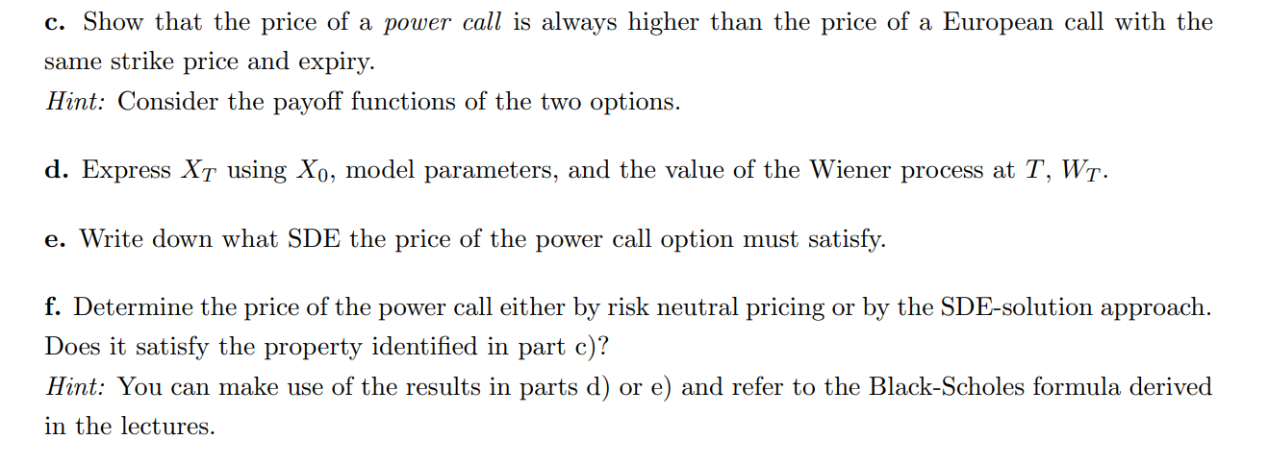
- Assume for contradiction $C_{P}<C_{E}$
Now look at the cashflows of selling a european and buying a Power, paying you
$$C_{E}-C_{P}>0$$
At time T
If $K>S_{T}$
$$\frac{1}{2}\max\left\{\frac{S^{2}}{K}-K,0\right\}-\max\left\{S-K,0\right\}=0$$
if$K≤S_{T}$
$$\frac{1}{2}max\left\{\frac{S^{2}}{K}-K,0\right\}-\max\left\{S-K,0\right\}=\frac{1}{2}\left(\frac{S^{2}}{K}-K\right)-\left(S-K\right)$$
$$=\frac{1}{2}\left(\frac{S^{2}}{K}-2S+K\right)=\frac{1}{2·K}{\left(S-K\right)}^{2}≥0$$
Thus we have a contradiction since no arbitrage states we cant only have negative or positive payoffs thus we must have negative cashflow at time 0
$$C_{E}-C_{P}≤0$$
$$C_{E}≤C_{P}$$
- We take the log process
$$d\log\left(X_{T}\right)=\left(\frac{1}{X_{T}}·X_{T}\left(2μ+σ^{2}\right)+\frac{1}{2}\left(-\frac{1}{X_{t}^{2}}·X_{t}^{2}\right)·4·σ^{2}\right)dt+2σ dW_{t}$$
$$=\left(\left(2μ-σ^{2}\right)\right)dt+2σ dW_{t}$$
Now we write up the equivalent statement
$$log\left(X_{T}\right)=\log\left(X_{0}\right)+T·\left(2μ-σ^{2}\right)+2σW_{T}$$
$$X_{T}=X_{0}·e^{T\left(2μ-σ^{2}\right)+2σW_{T}}=X_{0}·e^{T\left(2μ-σ^{2}\right)+2σ\sqrt{T}·W}$$
Where W is standard normal
- The Power calls price process must satisfy the BSM equation since we are in a BSM world
$$dC_{t}^{P}=\left(\frac{∂C_{t}^{P}}{∂t}+\frac{∂C_{t}^{P}}{∂S}·S_{t}·μ+\frac{1}{2}\frac{∂^{2}C_{t}^{P}}{∂S^{2}}·σ^{2}·S_{t}^{2}\right)dt+\frac{∂C_{t}^{P}}{∂S}·S_{t}·σ dW_{t}$$
A no arbitrage argument also implies
$$rC^{P}=\frac{∂C_{t}^{P}}{∂t}+\frac{∂C_{t}^{P}}{∂S}·S_{t}·μ+\frac{1}{2}\frac{∂^{2}C_{t}^{P}}{∂S^{2}}·σ^{2}·S_{t}^{2}$$
Which is the black scholes equation
- Under the risk neutral measure
Girsanovs theorem states if
$$dS_{t}=μ·S_{t} dt+σ·S_{t} dW_{t}$$
Then $dW_{t}^{Q}=dW_{t}+\frac{μ-r}{σ}$ thus
$$dS_{t}=μ·S_{t} dt+σ·S_{t} dW_{t}=r·S_{t} dt+σ·S_{t} dW_{t}^{Q}$$

We have been given a formula for pricing under the risk neutral measure in the BSM world
It just involves a nasty integral
$$E^{Q}\left[\frac{1}{2}\max\left\{\frac{S^{2}}{K}-K,0\right\}\right]=\int_{-∞}^{∞}{\frac{1}{2}\max\left\{\frac{S^{2}}{K}-K,0\right\}·\frac{1}{S}·\frac{1}{\sqrt{2·π·T} }·e^{\frac{\frac{-1}{2}\left(\log\left(S\right)-\log\left(s_{0}\right)-\left(r-\frac{σ^{2}}{2}\right)T\right)}{σ^{2}·T}}}ds$$
Now we just need to ”holde tungen lige I munden og løse den her satan” as we say in danish
The integral is 0 for $S<K$ so
$$=\frac{1}{2}\int_{K}^{∞}{\left(\frac{S^{2}}{K}-K\right)·\frac{1}{S}·\frac{1}{\sqrt{2·π·σ^{2}·T} }·e^{\frac{\frac{-1}{2}\left(\log\left(S\right)-\log\left(s_{0}\right)-\left(r-\frac{σ^{2}}{2}\right)T\right)}{σ^{2}·T}}}ds$$
We swap variables
$$y=\log\left(s\right)$$
$$\frac{dy}{ds}=\frac{1}{s}⇔ds=dy·s$$
And adjust the integral also note that $S=e^{y}$
$$=\frac{1}{2}\int_{\log\left(K\right)}^{∞}{\left(\frac{e^{2·y}}{K}-K\right)·\frac{1}{\sqrt{2·π·σ^{2}·T} }·e^{\frac{\frac{-1}{2}{\left(y{-\log\left(s_{0}\right)-\left(r-\frac{σ^{2}}{2}\right)T}\right)}^{2}}{σ^{2}·T}}}dy$$
We split it up
$$=\frac{1}{2}\int_{\log\left(K\right)}^{∞}{\frac{e^{2·y}}{K}·\frac{1}{\sqrt{2·π·σ^{2}·T} }·e^{\frac{\frac{-1}{2}{\left(y{-\log\left(s_{0}\right)-\left(r-\frac{σ^{2}}{2}\right)T}\right)}^{2}}{σ^{2}·T}}}dy$$
$$-\frac{1}{2}\int_{\log\left(K\right)}^{∞}{K·\frac{1}{\sqrt{2·π·σ^{2}·T} }·e^{\frac{\frac{-1}{2}{\left(y{-\log\left(s_{0}\right)-\left(r-\frac{σ^{2}}{2}\right)T}\right)}^{2}}{σ^{2}·T}}}dy$$
We swap variables
$$\frac{{\left(y{-\log\left(s_{0}\right)-\left(r-\frac{σ^{2}}{2}\right)T}\right)}^{2}}{σ^{2}·T}=x^{2}⇒x=\frac{y-\log\left(s_{0}\right)-\left(r-\frac{σ^{2}}{2}\right)T}{σ·\sqrt{T}}$$
$$\frac{dx}{dy}=\frac{1}{σ·\sqrt{T}}⇔dy=dx·σ·\sqrt{T}$$
We also note that this is function taken on $log⁡(K)$ is exactly $-d_{2}$ from the BSM equation for standard call and put
Also:
$$x=\frac{y-\log\left(s_{0}\right)-\left(r-\frac{σ^{2}}{2}\right)T}{σ·\sqrt{T}}$$

$$y=\frac{2·\sqrt{T}·σ·x-T·σ^{2}+2·\log\left(s_{0}\right)+2·T·r}{2}$$
These imply
$$=\frac{1}{2}\int_{-d_{2}}^{∞}{\frac{e^{2·\frac{2·\sqrt{T}·σ·x-T·σ^{2}+2·\log\left(s_{0}\right)+2·T·r}{2}}}{K}·\frac{1}{\sqrt{2·π} }·e^{-\frac{x^{2}}{2}}}dx$$
$$-\frac{1}{2}\int_{-d_{2}}^{∞}{K·\frac{1}{\sqrt{2·π} }·e^{-\frac{x^{2}}{2}}}dx$$
The second integral is exactly the standard normal CDF thus
$$-\frac{1}{2}\int_{-d_{2}}^{∞}{K·\frac{1}{\sqrt{2·π} }·e^{-\frac{x^{2}}{2}}}dx=-\frac{K}{2}\int_{-d_{2}}^{∞}{\frac{1}{\sqrt{2·π} }·e^{-\frac{x^{2}}{2}}}dx=-\frac{K}{2}(1-\int_{-∞}^{{-d}_{2}}{\frac{1}{\sqrt{2·π} }·e^{-\frac{x^{2}}{2}}}dx)$$
$$=-\frac{K}{2}N\left(d_{2}\right)$$
Now to the harder part
$$=\frac{1}{2}\int_{-d_{2}}^{∞}{\frac{e^{2·\frac{2·\sqrt{T}·σ·x-T·σ^{2}+2·\log\left(s_{0}\right)+2·T·r}{2}}}{K}·\frac{1}{\sqrt{2·π} }·e^{-\frac{x^{2}}{2}}}dx$$
$$=\frac{1}{2K}·\int_{-d_{2}}^{∞}{e^{2·\sqrt{T}·σ·x-T·σ^{2}+2·\log\left(s_{0}\right)+2·T·r}·\frac{1}{\sqrt{2·π} }·e^{-\frac{x^{2}}{2}}}dx$$
$$=e^{2rT}·\frac{S^{2}}{2K}·\int_{-d_{2}}^{∞}{e^{2·\sqrt{T}·σ·x-T·σ^{2}}·\frac{1}{\sqrt{2·π} }·e^{-\frac{x^{2}}{2}}}dx$$
We wish for a way to make it standard normal again we get the grat idea to make a square
$$2·\sqrt{T}·σ·x-T·σ^{2}-\frac{x^{2}}{2}$$
$$\frac{4·\sqrt{T}·σ·x-2T·σ^{2}-x^{2}}{2}$$

$$\frac{4·\sqrt{T}·σ·x-2T·σ^{2}-x^{2}}{2}-Tσ^{2}=-\frac{{\left(x-2σ\sqrt{T}\right)}^{2}}{2}+Tσ^{2}$$
$$e^{2rT}·\frac{S^{2}}{2K}·\int_{-d_{2}}^{∞}{e^{2·\sqrt{T}·σ·x-T·σ^{2}}·\frac{1}{\sqrt{2·π} }·e^{-\frac{x^{2}}{2}}}dx$$
$$=e^{2rT}·\frac{S^{2}}{2K}·\int_{-d_{2}}^{∞}{e^{T·σ^{2}}·\frac{1}{\sqrt{2·π} }·e^{-\frac{{\left(x-2σ\sqrt{T}\right)}^{2}}{2}}}dx$$
We change variables again
$$z=x-2σ\sqrt{T}$$
$$\frac{dz}{dx}=1$$
$$=e^{2rT}·\frac{S^{2}}{2K}·e^{T·σ^{2}}·\int_{-d_{2}-2σ\sqrt{T}}^{∞}{\frac{1}{\sqrt{2·π} }·e^{-\frac{{\left(z\right)}^{2}}{2}}}dz=e^{(2r+σ^{2})T}·\frac{S^{2}}{2K}·N(d_{2}+2σ\sqrt{T})$$
The price of a general derivative is given as
$$F_{0}=E^{Q}[d_{0,t}·F_{T}]$$
Since continuous compounding in the BSM world
$$C_{0}^{P}=E^{Q}\left[d_{0,T}·C_{T}^{P}\right]=e^{-rT}·[e^{\left(2r+σ^{2}\right)T}·\frac{S^{2}}{2K}·N\left(d_{2}+2σ\sqrt{T}\right)-\frac{K}{2}·N\left(d_{2}\right)]$$
$$=e^{\left(r+σ^{2}\right)T}·\frac{S^{2}}{2K}·N\left(d_{2}+2σ\sqrt{T}\right)-\frac{K}{2}N\left(d_{2}\right)·e^{-rT}$$
Price must be higher since
$$C^{P}-C^{E}=e^{-rt}·E^{Q}\left[{\left(S-K\right)}^{2}·I_{S>K}\right]≥0$$
Ive tried to compare prices directly but cant find a nice way to express it neatly
I suppose we could calculate this expectation under Q but id rather not

